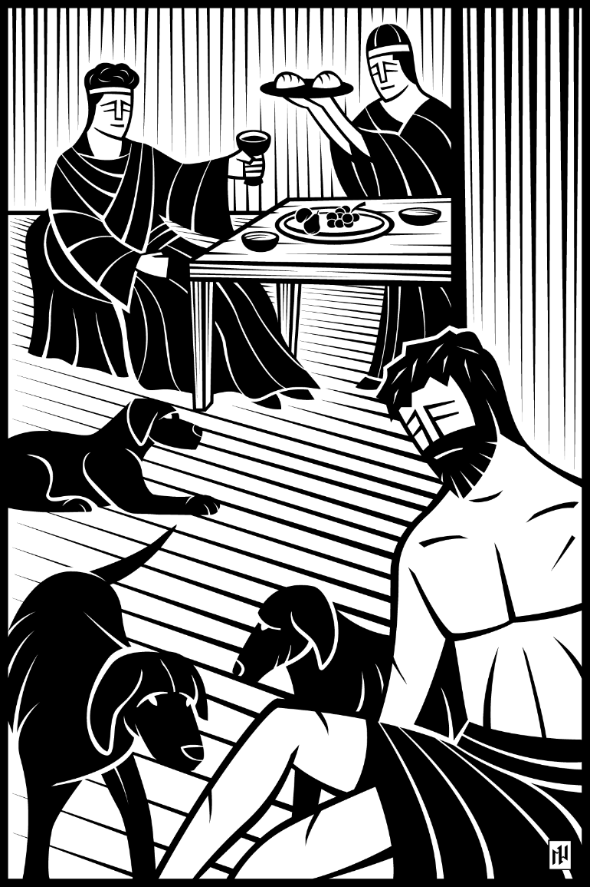

Sixteenth Sunday after Pentecost
at
  - Abiding Grace Evangelical Lutheran Church
  - Hampton, GA
  - … where families connect

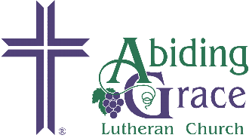
Abiding Grace
Lutheran Church
September 24th, 2017
Prayer before worship
Almighty, ever-living God, grant that I may gladly hear your Word and that all my worship may be acceptable to you; through Jesus Christ, my Lord. Amen.
Sixteenth Sunday after Pentecost
W
elcome to God’s house for worship this morning. We’re glad you are here. In our service we gather before our Almighty God to offer him our worship and praise. We also gather to be strengthened through the study of God’s holy and powerful Word and grow closer to one another.
The Bulletin that you are holding has the entire Order of Service for today’s worship printed out for you.
Hymnals, the red books on the seats, are used for singing during our worship.
Ushers are available and happy to assist you with whatever you may need. Please ask the men near the back of the room or at the entrance doors.
Babies and young ones are welcome and encouraged to worship with us. We are glad to hear their occasional, spontaneous “joyful noises.” Children’s church bags can be found by either entrance to help them focus. If, however, you feel that your child is growing overly disruptive and they need to walk around, you are welcome to use the gathering area or the play area up the ramp by the church entrance.
Restrooms are found through the gathering area to your right as you leave the sanctuary.
The Lord’s Supper is offered during today’s service. Because of God’s specific instructions regarding the Lord’s Supper, if you are not a member of this or one of our sister congregations (WELS or ELS), please schedule a time to speak with one of the pastors before receiving the Lord’s Supper here.
Our Worship Today
Theme: I share Christ in my community through lavish service, not lazy luxury
- We have come to know the Savior who has forgiven all our sins, given us peace with God, and the sure hope of everlasting life. We naturally want to share this good news with others. Today we’ll look at one way to do that: lavish service.

The Divine Service
Our service is introduced by music from the piano and a welcome from the presiding minister (also known as the “liturgist”).

Opening Hymn Send the Light, verses 1-3 (printed on page 4)

Invocation
L(iturgist): In the name of the Father, and of the Son , and of the Holy Spirit.
C(ongregation): Amen.
Invocation
The invocation affirms that our worship begins in the name of and directed toward the one, true, Triune God of the Bible.

Confession and Absolution
L: Dear friends, let us approach God with a true heart and confess our sins, asking him in the name of our Lord Jesus Christ to forgive us.
C: Lord of life, I confess that I am by nature dead in sin.
For faithless worrying and selfish pride,
For sins of habit and sins of choice,
For the evil I have done and the good I have failed to do,
You should cast me away from your presence forever.
O Lord, I am sorry for my sins. Forgive me, for Jesus’ sake.
Absolution
In the absolution, we receive God’s promise from 1 John 1:9, “If we confess our sins he is faithful and just, and will purify us from all unright-eousness.”
L: Christ has died. Christ is risen. Christ will come again. In his great mercy, God made us alive in Christ even when we were dead in our sins. Hear the word of Christ through his called servant: I forgive you all your sins in the name of the Father and of the Son and of the Holy Spirit.
C: Amen.

Opening Hymn Send the Light, verses 1-3 (lyrics only)

¹ There’s a call comes ringing
o’er the restless wave,
“Send the light! Send the light!”
There are souls to rescue
there are souls to save,
Send the light! Send the light!
Chorus
² We have heard the
Macedonian call today,
“Send the light! Send the light!”
And a golden off’ring
at the cross we lay,
Send the light! Send the light!
Chorus

³ Let us pray that grace
may ev’rywhere abound,
“Send the light! Send the light!”
And a Christian spirit
ev’rywhere be found
Send the light! Send the light!
Chorus

Chorus
Send the light, the blessed gospel light;
Let it shine from shore to shore!
Send the light, the blessed gospel light;
Let it shine forevermore!

Prayer and Praise

Lord, Have Mercy - Kyrie
L: In peace, let us pray to the Lord.
Kyrie
Kyrie is the Greek word for Lord. The expression, “Lord, have mercy” is one of the oldest worship responses in the Christian church.

For the well-being of all people everywhere, that they may receive from you all they need to sustain body and life, hear our prayer, O Lord.
C: Lord, have mercy.
L: For the spread of your life-giving gospel throughout the world, that all who are lost in sin may be brought to faith in you, hear our prayer, O Christ.
C: Christ, have mercy.
L: For patience and perseverance in this life, that we may not lose the hope of heaven as we await your return, hear our prayer, O Lord.
C: Lord, have mercy.
L: Lord of life, live in us that we may live for you.
C: Amen.

Glory to God – Gloria in Excelsis tune from hymn 84 Luke 2:14
Gloria in Excelsis
This song with roots in the 4th century proclaims the great things God has done to rescue us from sin, death, and the devil.

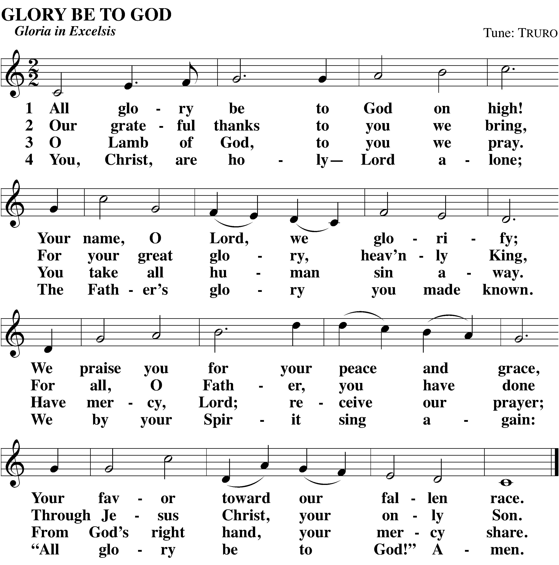

Salutation
Salutation
This greeting has deep roots in Christian worship and marks the section of the service that focuses on readings from God’s Word, the Holy Bible.

L: The Lord be with you.
C: And also with you.

Prayer of the Day
L: Let us pray.
Mercifully grant, O God, that your Holy Spirit may in all things direct and rule our hearts, for without your help we are unable to please you; through Jesus Christ, your Son, our Lord, who lives and reigns with you and the Holy Spirit, one God, now and forever.
C: Amen.
The Word of God
Scripture Readings
God’s Word has been at the center of Christian worship since the time of the Apostles (Acts 2:42). The readings are thematically tied to the Gospel of the Day, which is the high point of the readings.. Similar to the way we honor those in a parade by standing, we honor our Lord by standing during the Gospel of the Day.

First Lesson Amos 6:1-7
Our Scripture readings for the day can be found on the insert.

Children’s Sermon
The children are invited to come forward for a message directed especially toward them.

Psalm of the Day Psalm #146
The liturgist and the congregation speak the psalm responsively. You will find the psalm on the bulletin insert.

Second Lesson Hebrews 13:1-6
Our Scripture readings for the day can be found on the insert.

Verse of the Day Philippians 2:10,11
L: Alleluia! At the name of Jesus every knee should bow, and every tongue confess that Jesus Christ is Lord, to the glory of God the Father.
C: Alleluia!

Gospel of the Day Luke 16:19-31
Please stand.
After the announcement of the Gospel, the congregation says:
C: Glory be to you, O Lord.
Our Scripture readings for the day can be found on the insert.
L: This is the Gospel of our Lord.
C: Praise be to you, O Christ.
Please be seated.

Hymn of the Day #184 O Holy Spirit, Enter In

Sermon Amos 6:1-7
Jesus endured the evil day for you
- To save sinners who live in lazy luxury
- To turn you from selfishness toward lavish service

Confession of Faith Nicene Creed
Nicene Creed
Public confession is faith’s response to God’s saving Word. The Nicene Creed has been confessed by Christians since the fourth century as a proclamation of the true Christian faith in the one, true, Triune God, and especially in the deity of Jesus. Christians all over the world confess this creed to tell others what they believe, and to confess their faith together in worship.
Please stand.
We believe in one God, the Father, the Almighty,
maker of heaven and earth,
of all that is,
seen and unseen.
We believe in one Lord, Jesus Christ, the only Son of God,
eternally begotten of the Father,
God from God, Light from Light, true God from true God,
begotten, not made,
of one being with the Father.
Through him all things were made.
For us and for our salvation, he came down from heaven,
was incarnate of the Holy Spirit and the virgin Mary,
and became fully human.
For our sake he was crucified under Pontius Pilate.
He suffered death and was buried.
On the third day he rose again in accordance with the Scriptures.
He ascended into heaven
and is seated at the right hand of the Father.
He will come again in glory to judge the living and the dead,
and his kingdom will have no end.
We believe in the Holy Spirit,
the Lord, the giver of life,
who proceeds from the Father and the Son,
who in unity with the Father and the Son is worshiped and
glorified,
who has spoken through the prophets.
We believe in one holy Christian and apostolic Church.
We acknowledge one baptism for the forgiveness of sins.
We look for the resurrection of the dead
and the life of the world to come. Amen.
Please be seated.

Offering
The members of Abiding Grace Evangelical Lutheran Church have joined together to do the Lord’s work in this community and throughout the world. During the offering, please take a moment to fill in the Friendship Register that is being handed down your aisle. After everyone has signed it, you may place it on the floor beneath the chair at the end of the row.
Public Prayer
God invites our prayers and desires that Christians pray for many people and circumstances (1 Timothy 2:1-4).

Reception of New Members
Toni and Destin Smith, sister and nephew of Brenda Held, transfer their membership from our sister church, Community Lutheran Church in Honolulu, HI.

Prayer of the Church
As the prayer is spoken, each time the minister says, “Lord, in your mercy…” the congregation is invited to respond, “Hear our prayer.”
Sacrament of Holy Communion

Preface
L: The Lord be with you.
C: And also with you.
L: Lift up your hearts.
C: We lift them up to the Lord.
Preface
The Preface mark the beginning of the Sacrament section of the service. These opening sentences are among the oldest in the Christian liturgy.
L: Let us give thanks to the Lord our God.
C: It is good and right so to do.
L: It is truly good and right that we should at all times and in all places give you thanks, O Lord, holy Father, almighty and everlasting God, through Jesus Christ, our Lord who has called us to be his own so that we may live under him in his kingdom and serve him in everlasting righteousness, innocence, and blessedness. Therefore with all the saints on earth and hosts of heaven, we praise your holy name and join their glorious song:
The congregation sings the Sanctus on the next page.

Holy, Holy, Holy – Sanctus tune from hymn 166
Sanctus
“Santcus” means “holy.” Used possibly as early as the 2nd century, this canticle was in wide use among Christians during worship by the 14th century.
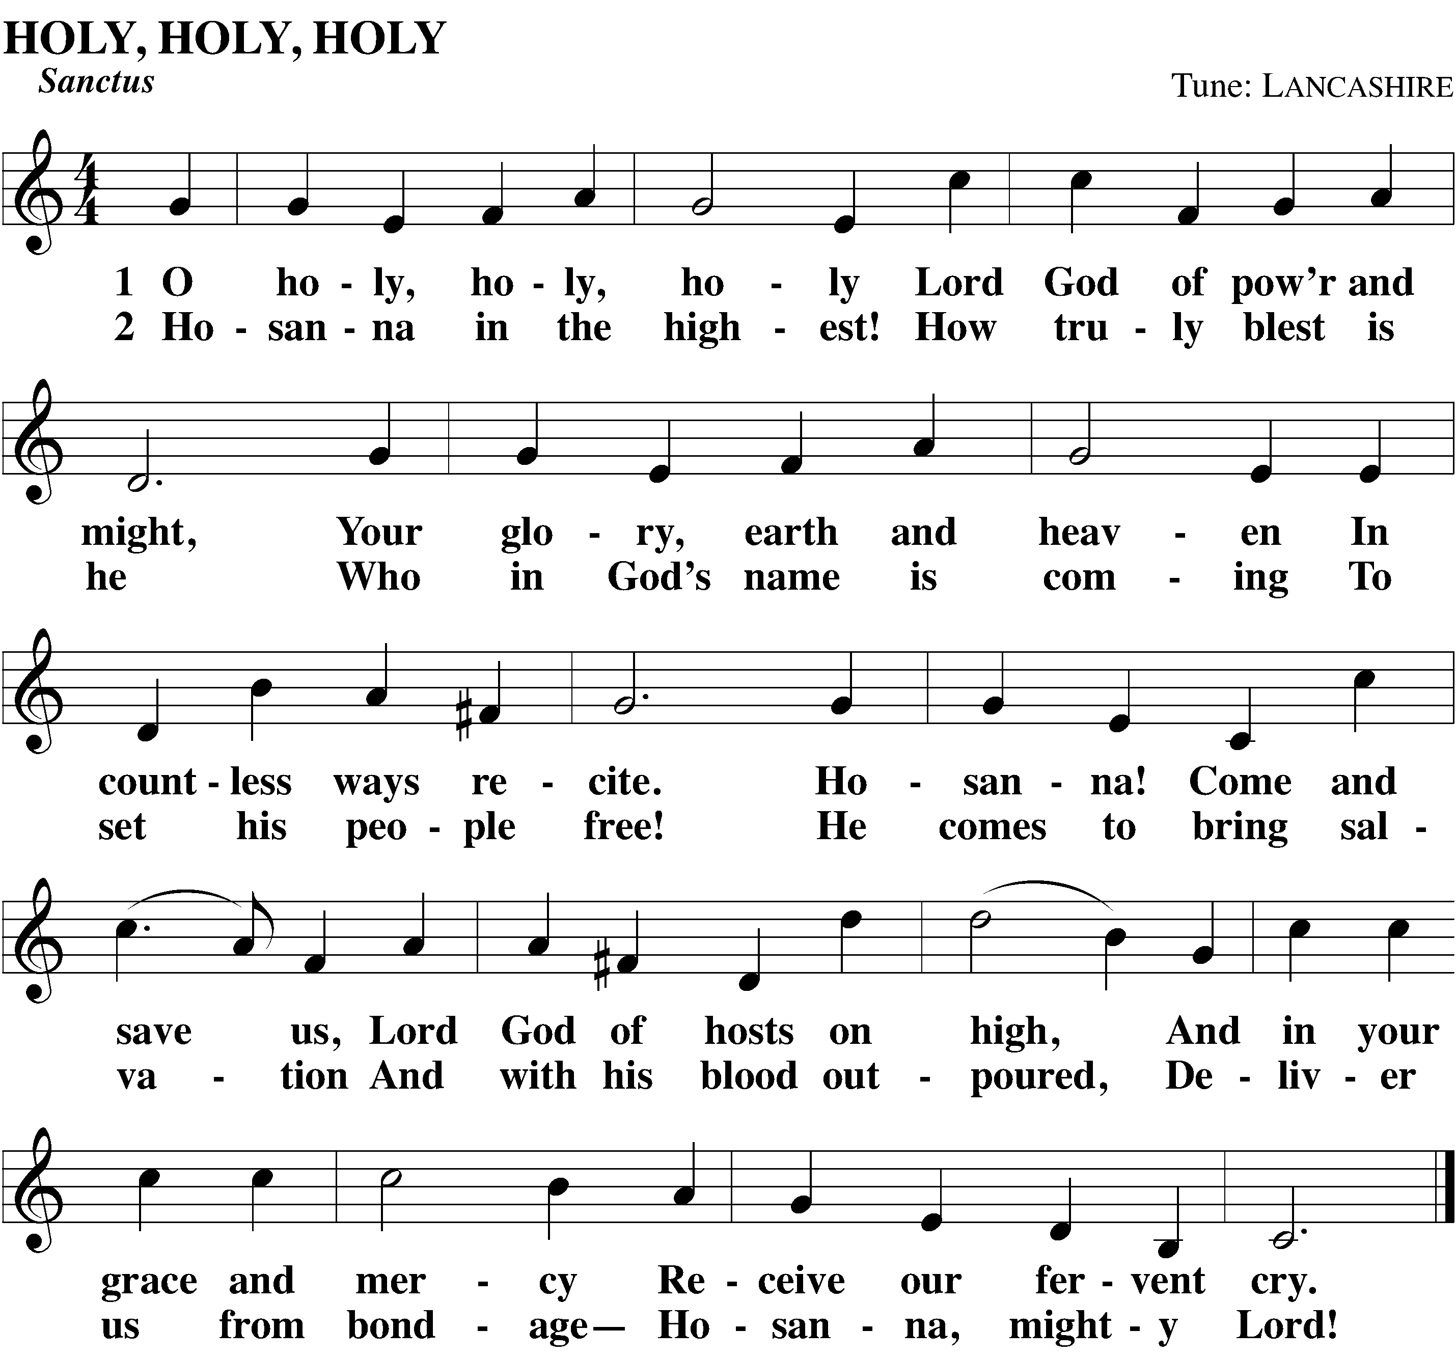

Prayer of Thanksgiving
L: Blessed are you, O Lord of heaven and earth. We praise and thank you for sending your Son, Jesus Christ, and we remember the great acts of love through which he ransomed us from sin, death, and the devil’s power.
By his incarnation, he became one with us.
By his perfect life, fulfilled your holy will.
By his innocent death, he overcame hell.
By his rising from the grave, he opened heaven.
Invited by your grace and instructed by your Word, we approach your table with repentant and joyful hearts. Strengthen us through Christ’s body and blood, and preserve us in the true faith until we feast with him and all his ransomed people in glory everlasting.
C: Amen.

The Lord’s Prayer spoken by the congregation
Words of Institution
In the Words of Institution, the pastor both proclaims the words of Jesus to the congregation and sets apart the bread and wine for the Lord’s use.
Our Father, who art in heaven,
hallowed be thy name,
thy kingdom come,
thy will be done
on earth as it is in heaven.
Give us this day our daily bread;
and forgive us our trespasses,
as we forgive those
who trespass against us;
and lead us not into temptation,
but deliver us from evil.
For thine is the kingdom
and the power and the glory
forever and ever. Amen.

Words of Institution Matthew 26:26-28; 1 Corinthians 11:24,25
L: Our Lord Jesus Christ, on the night he was betrayed, took bread; and when he had given thanks, he broke it and gave it to his disciples, saying, “Take and eat; this is my body, which is given for you. Do this in remembrance of me.”
Then he took the cup, gave thanks, and gave it to them, saying, “Drink from it all of you; this is my blood of the new covenant, which is poured out for you for the forgiveness of sins. Do this, whenever you drink it, in remembrance of me.”
L: The peace of the Lord be with you always.
C: Amen.

Lamb of God – Agnus Dei
Membership Communion
Christ desires for believers to come to the Lord’s Supper in repentance, completely united in faith, and fully knowing what they receive in this Sacrament. The Bible warns that if we come to the Lord’s Supper in unrepentance, in disunity, or without full knowledge and faith in what is happening, we receive Christ’s body and blood to our judgment, not benefit
(1 Corinthians 11:27-32). Membership communion is a loving practice to offer the Lord’s Supper to people’s benefit, not their detriment.
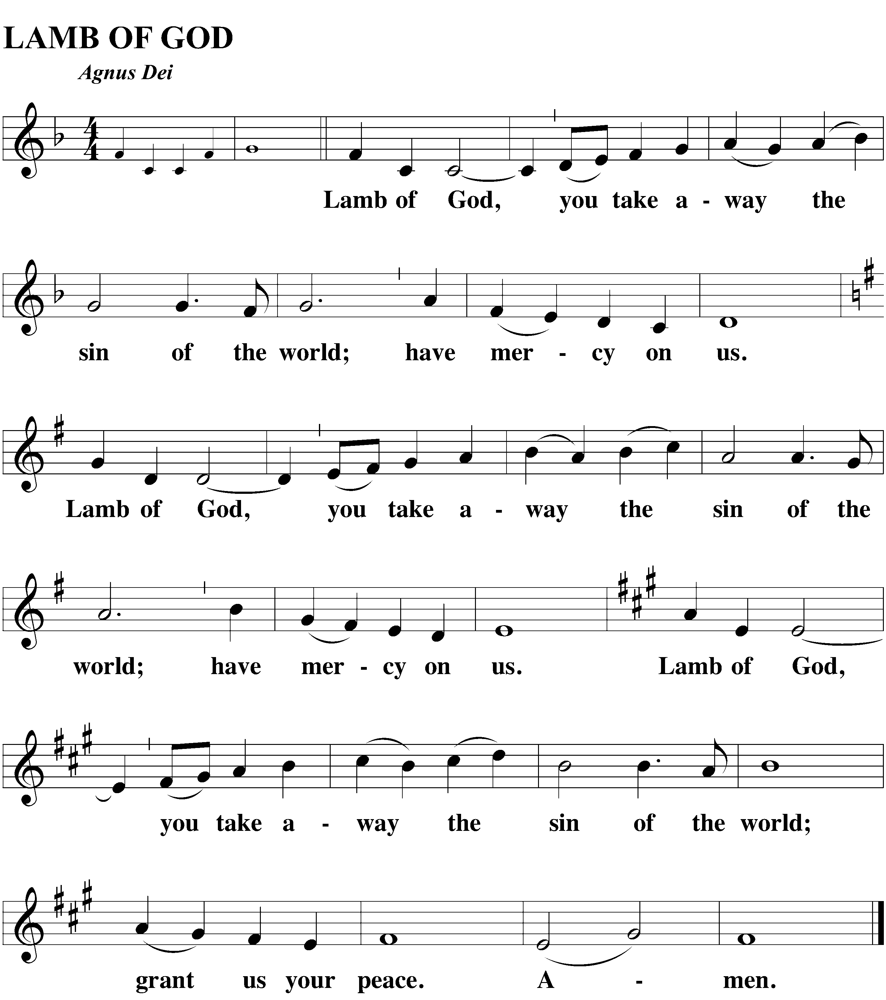

Distribution
Please follow the directions of the ushers. Following the distribution, the congregation joins to sing the Song of Simeon (Nunc Dimittis) on the following page.

Song of Simeon – Nunc Dimittis tune from hymn 336
Nunc Dimittis
The “Nunc Dimittis” (“Now Dismiss”) is also known as the “Song of Simeon.” Through God’s Word and Sacrament we have seen Jesus Christ, and like Simeon we find divine peace and comfort through faith in the Savior. Therefore, we commend our lives to him, trusting his promises to care for both our bodies and souls and finally lead us to our heavenly home.
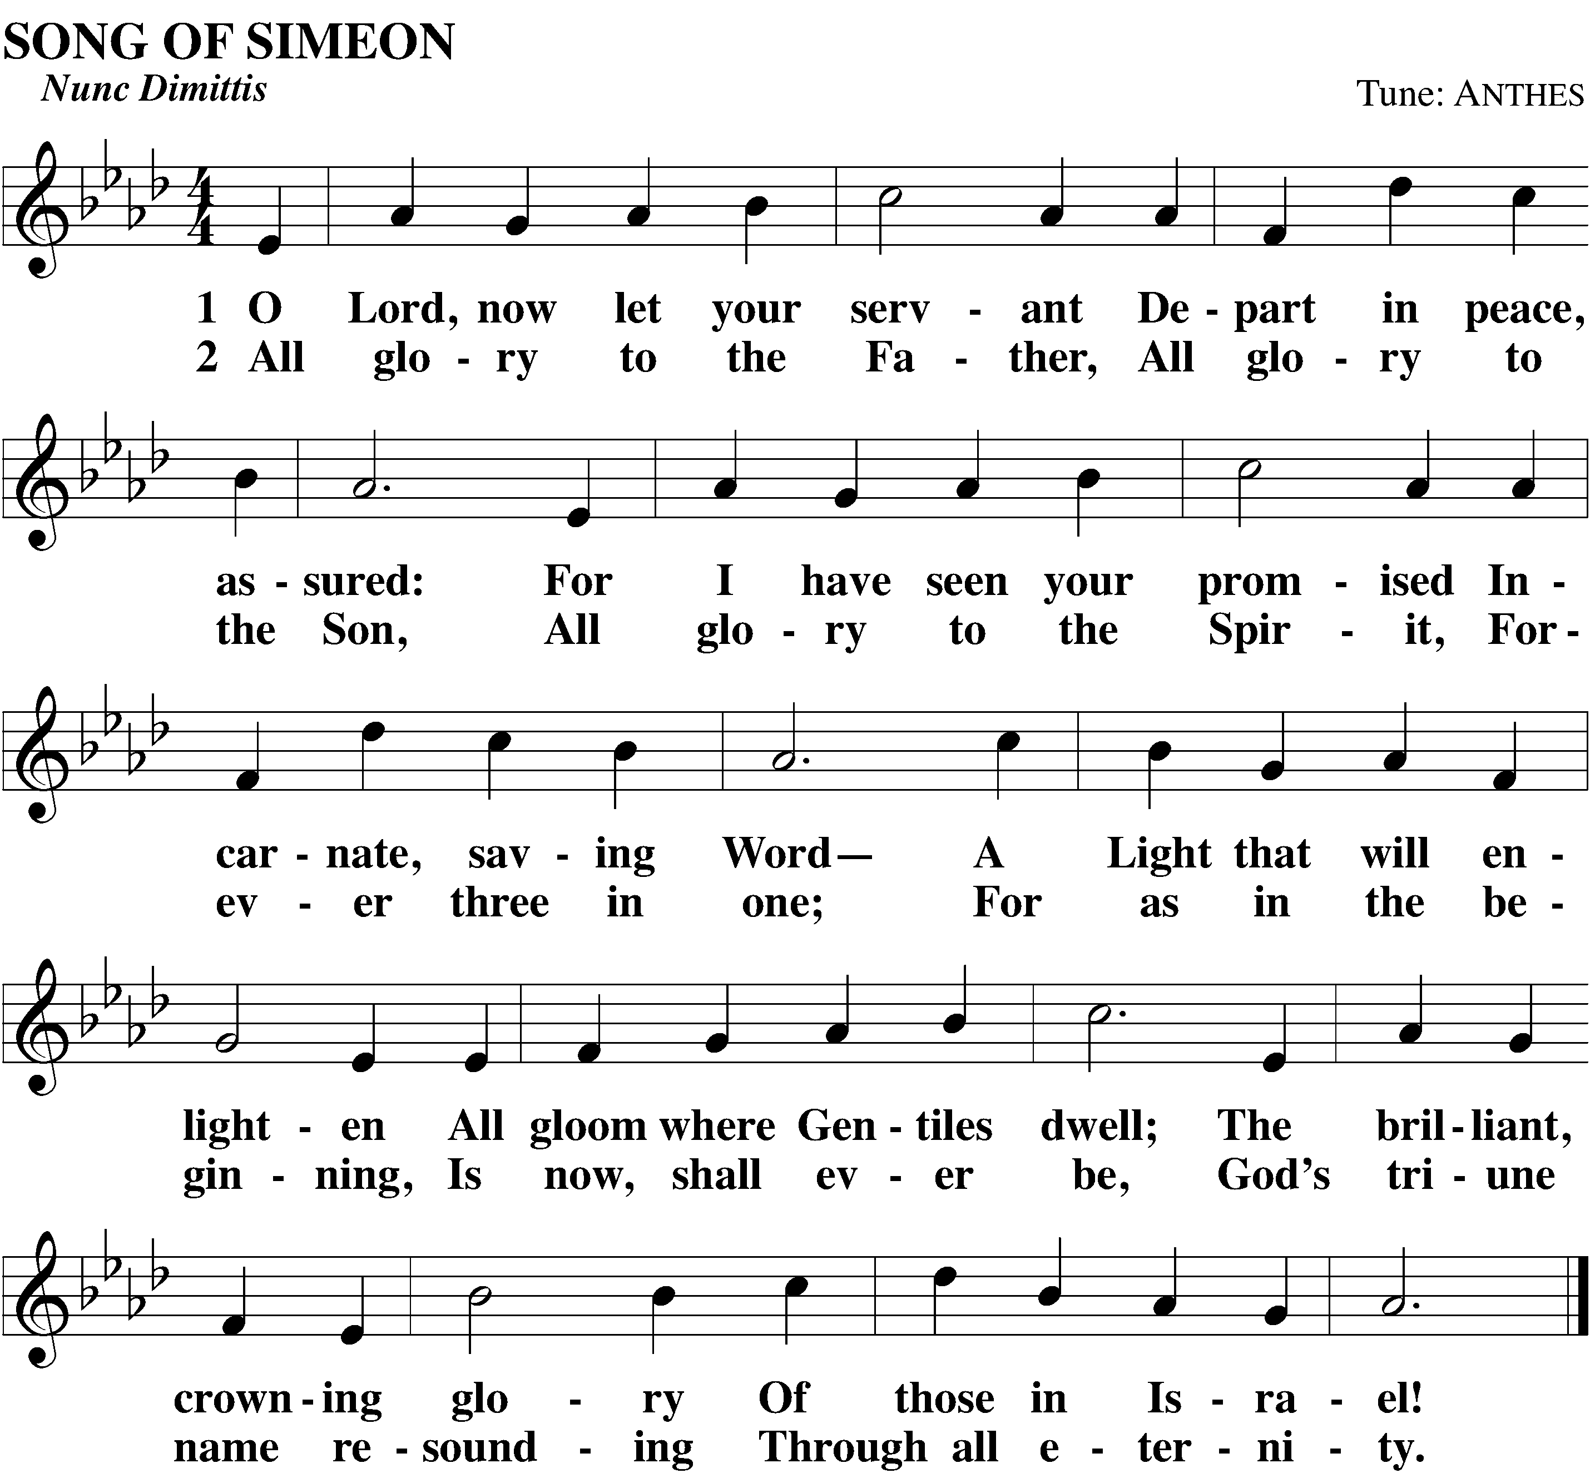

Closing Prayer
L: We give you thanks, O Lord, for the foretaste of the heavenly banquet that you have given us to eat and to drink in this sacrament. Through this gift you have fed our faith, nourished our hope, and strengthened our love. By your Spirit help us to live as your holy people until that day when you will receive us as your guests at the wedding supper of the Lamb, who lives and reigns with you and the Holy Spirit, one God, now and forever.
C: Amen.

The Lord’s Blessing
Aaronic Blessing
The blessing of Aaron has been spoken over God’s people for over 3,500 years. The Lord said, “So they will put my name on [them], and I will bless them” (Numbers 6:27).
L: Brothers and sisters, go in peace. Live in harmony with one another. Serve the Lord with gladness.
The Lord bless you and keep you.
The Lord make his face shine on you and be gracious to you.
The Lord look on you with favor and give you peace.
C: Amen.

Closing Hymn #562 I Love to Tell the Story
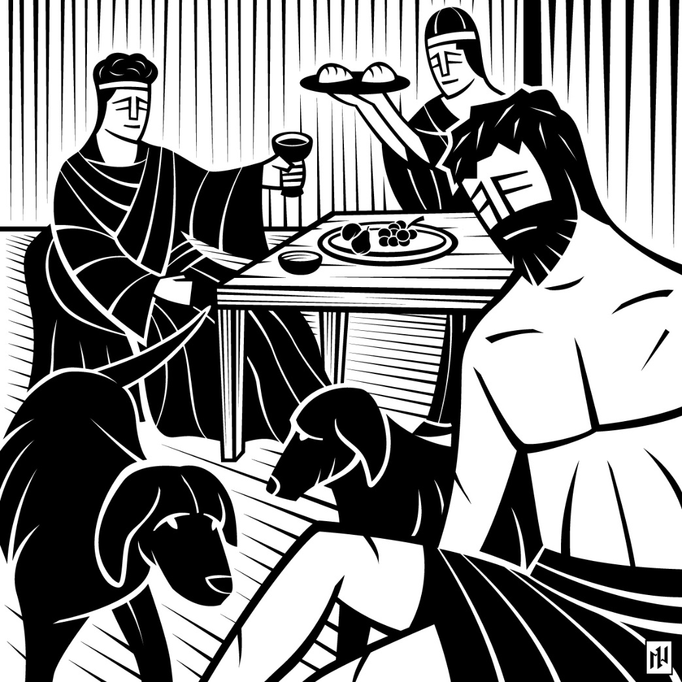

Welcome and Thank You For Worshiping With Us
Prayer After Worship
Almighty God, grant that the Word which I have heard this day may through your grace be so planted in my heart that I may bring forth the fruit of the Spirit; through Jesus Christ, my Lord. Amen.
It is wonderful to have all of you here with us today to worship our amazing God. Please stick around after worship to meet and get to know better your brothers and sisters in Christ.
If the Spirit has worked through His Word today and moved you to want to find out more or to get involved – please speak to Pastor Steenbock or any of the members after worship. You can also get a hold of Pastor Steenbock or the other ministry staff at Abiding Grace using the contact information below. If you have any questions or comments about anything that went on here or what was taught, again, please speak to Pastor Steenbock or any of the members after worship. And come again next week as we join together to worship Jesus, revealed clearly as our Savior. See the announcements and calendar following for other Bible Study, fellowship, and service opportunities.

Abiding Grace Contact Information

Pastor Benjamin Steenbock
Cell: (770) 707-2144
Email: pastorben@abidinggrace.com
Pastor Jonathan Scharf
Cell: (404) 218-7568
Email: pastor@abidinggrace.com
Vicar Steven Saatkamp
Cell: (414) 828-9991
Email: vicar@abidinggrace.com
Church Offices
Henry County: (770) 707-2144
Newton County: (770) 385-7691

Acknowledgements
Presiding Minister: Pastor Benjamin Steenbock
Preacher: Pastor Benjamin Steenbock
Accompanist(s): Mrs. Becky Reid
Divine Service II. Words & Music: © 2008 Northwestern Publishing House. All rights reserved. Reprinted under OneLicense.net #A-714318.
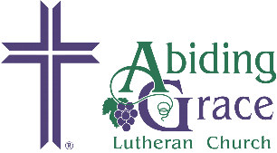

Coming Events

Ongoing Weekly Activities
Sundays at 9:15am Sunday School and Adult Bible Study
Sundays at 10:30am Worship
Wednesdays at 6:45pm Confirmation (Middle School ages, at Newton County site)
Wednesdays at 7pm Adult Bible Study (at Newton County site)
Wednesdays at 7pm Teen Bible Study (High School ages, at Newton County site)
Wednesdays at 7pm Kids Club (ages 0-10, at Newton County site)
Fridays at 9am Building on the Rock (for developmentally disabled, at Newton County site)
Saturdays at 10am Canvassing

Upcoming Special Events
Sundays, 1:00pm Sep 17-Nov 19 Financial Peace University course
Sat. September 23, 2:00pm Seminar: Confidently Sharing Jesus with Friends
Sun. September 24, 12:15pm 45-minute Workshop: Community Outreach at Abiding Grace
Late September Outreach Opportunity: McDonough Scarecrow Contest
Sat. October 14 8am-6pm Outreach Opportunity: Bear Creek Festival
Sun. October 15, 10:30am Fall Festival – Mark your calendars. Invite your friends!
Sat. October 28, 2:00pm Seminar: Confidently Sharing Jesus with Friends
Sun. October 29, 12:15pm 45-minute Workshop: Community Outreach at Abiding Grace
Sun. October 29, Time TBA Circuit Reformation Festival Service at Newton County campus
Sun. November 19, 12:00pm Semiannual Voters Meeting

Receive Daily Devotions and Church Updates in Your Email
If you’re not already getting daily devotions and church updates in your email, go to the links below and sign up!
- Daily Devotions: http://eepurl.com/bA_6dL
- Weekly Sermons: http://eepurl.com/bxNb_D
- Invitations and Upcoming Events: http://eepurl.com/dJ-EA
- Weekly Bulletin Announcements: http://eepurl.com/dSY19

